

Project Name : Calligraphy

Presented by: Barira shoukat

DOCUMENTATION

**ACKNOWLEDGMENT**

I am really grateful because we managed to complete our E-project within the time given by Aptech.

Miss **Syeda Arooj Zahra**. This assignment cannot be completed without the effort and co-operation from our teacher. I also thank graphic designer Mr. Asad for assisting in Logo designing.

I also sincerely thank our teacher for the guidance and encouragement in finishing this project and also for teaching us in this course.

Last but not the least, we would like to express we gratitude to our friends and respondents for the support and willingness directly or indirectly to spend some times with me to fill in the questionnaires.

**Introduction**

The thirst for learning, upgrading technical skills and applying the concepts in real life environment at a fast pace is what the industry demands from IT professionals today. However busy work schedules, far-flung locations, unavailability of convenient time-slots pose as major barriers when it comes to applying the concepts into realism.  And hence the need to look out for alternative means of implementation in the form of laddered approach.

The above truly pose as constraints especially for our students too! With their busy schedules, it is indeed difficult for our students to keep up with the genuine and constant need for integrated application which can be seen live especially so in the field of IT education where technology can change on the spur of a moment. *Well, technology does come to our rescue at such times!!*

Keeping the above in mind and in tune with our constant endeavor to use Technology in our training model, we at Aptech have thought of revolutionizing the way our students learn and implement the concepts using tools themselves by providing a *live and synchronous e-project learning environment!*

**What is this e-Project?**

e-Project is a step-by-step learning environment that closely simulates the classroom and Lab based learning environment into actual implementation. It is a project implementation at your fingertips!! An electronic, live juncture on the machine that allows you to

* Practice step by step i.e. laddered approach.
* Build a larger more robust application.
* Usage of certain utilities in applications designed by user.
* Single program to unified code leading to a complete application.
* Learn implementation of concepts in a phased manner.
* Enhance skills and add value.
* Work on real life projects.
* Give a real-life scenario and help to create applications more complicated and useful.
* Mentoring through email support.

The students at the center are expected to complete this e-Project and send complete project along with the documentation to e-Project Team

Looking forward to a positive response from your end!!

**Objectives of the project**:

The merely objective of this project was to put in practice what we learnt in semester. HTML5, CSS3, JS, Bootstrap 5.3. This website made entirely on these soft skills

PROJECT: **Scratchy Nib**

**Problem Statement**

Calligraphy has become very popular recently – examples of it can be seen in many advertising areas, restaurant menus, posters and even party invitations. It’s very loosely based on Copperplate calligraphy, which is a lot stricter in form and design. Scratchy Nib is one place, which brings together the art of Calligraphy along with the knowledge and history. You are supposed to create a Single-Page-Application and responsive Website for them with the below mentioned requirement specifications. The website should work well in all leading browsers including Chrome, IE, Firefox

etc.

**Functional Requirement Specification:**

The portal will be designed as a Single-Page-Application and responsive Website with a set of pages and menus that represent choice of activities to be performed. The pages, menus, and other visual elements must be designed in a visually appealing manner with attractive fonts, colors, and animations.

1) Top of the website should have Title in Calligraphic and should provide brief

information about calligraphy as from where it originated etc.

2) There should be a well-designed menu with all sections listed.

3) Various sections such as Traditional Calligraphy, Contemporary Calligraphy,

Hand-lettering &amp; Design, Modern Calligraphy etc. should be provided.

4) Section explaining various forms and styles should be provided.

5) Filter on designs as Arabic, Indic, Greek etc should be provided.

6) Proper description of the letters and fonts must be added in the website.

7) Gallery should be added for viewing different Calligraphic styles.

8) Feedback must be allowed to enter by the viewer.

9) Site map, Gallery, about us, Queries link, Contact us link must be added.

10) About Us and Contact Us: This menu option should display Email id, address,

and contact number of the organization4.

11) Color combination must be uniform throughout the project.

12) Navigation must be smooth.

Over and above this, the portal should implement the following functionalities:

• Display a continuous scrolling ticker at the bottom of the page with current date,

time, and location (hint: Use geolocation features of HTML5).

• Display a visitor count at the top right corner of the page beside a logo image.

• The menu options should change color on hover and also after clicking.

• Fade in and fade out options can be used for the menus.

**WORK ANALYSIS:**

|  |  |
| --- | --- |
| Task | Barira Shoukat |
| Analysis |  |
| Design |  |
| Coding |  |
| Testing |  |
| Documentation |  |

**Home Page Design:**

**Visual Representation**

|  |
| --- |
| Header |
| Logo & Navigation bar |
| Hero Section |
| About us |
| Categories of calligraphy­­ |
| Gallery |
| Forms & styles |
| Filters |
| Fonts & Letters |
| Rating |
| Contact Us |
| Footer |

**1.Header:**



**Code:**

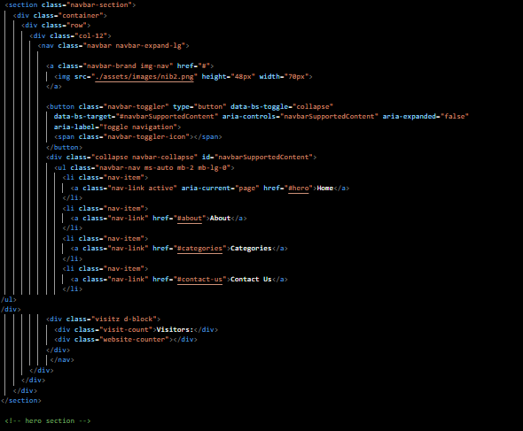

2.Home Page

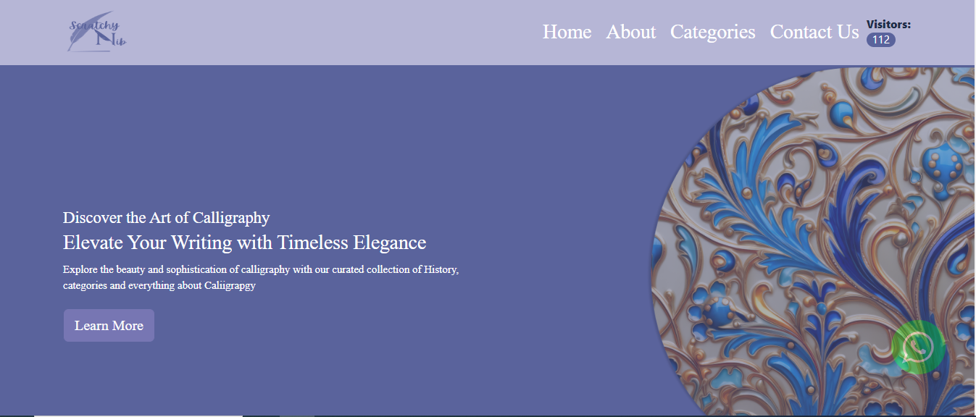

**Code:**

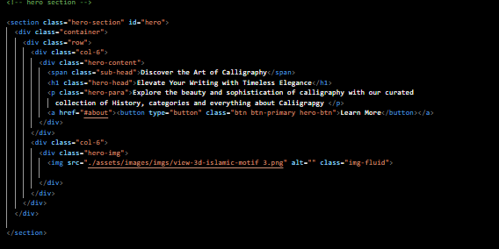

**3. About us:**

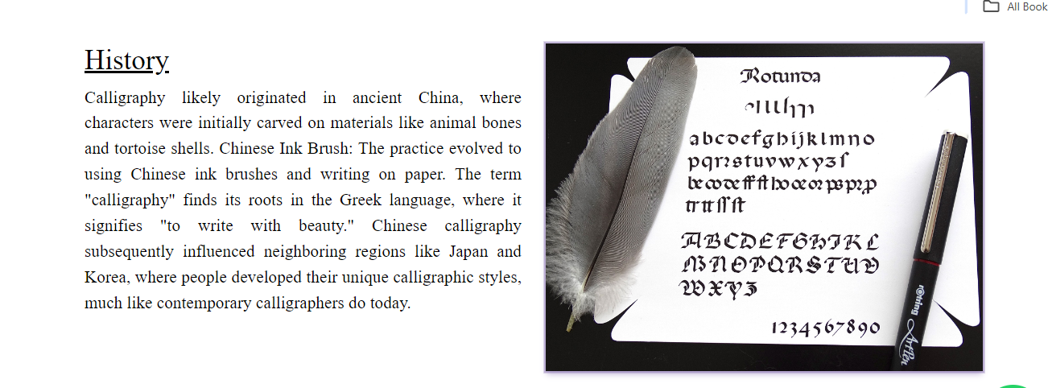

**Code:**

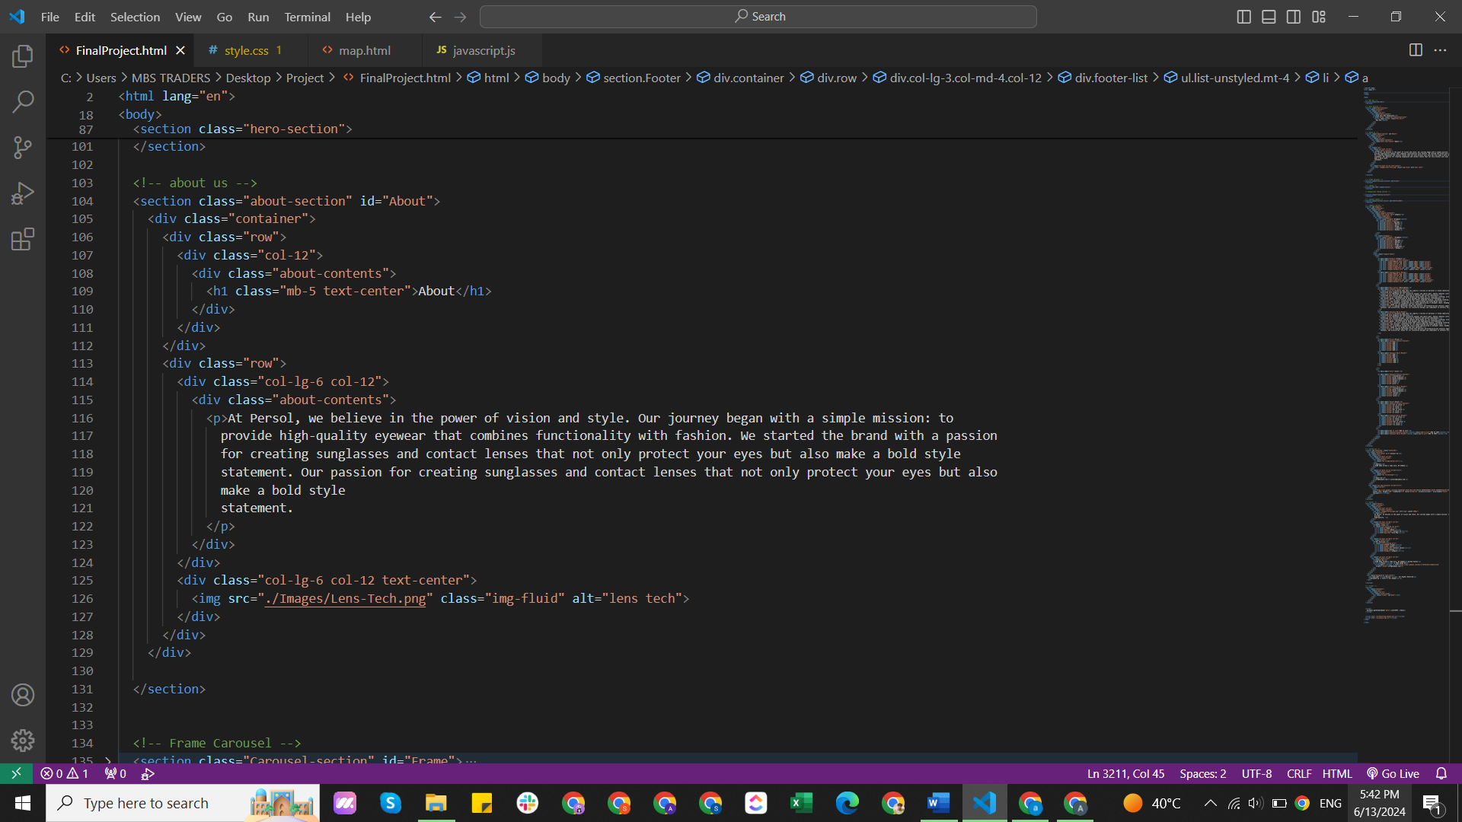

**4. Categories:**

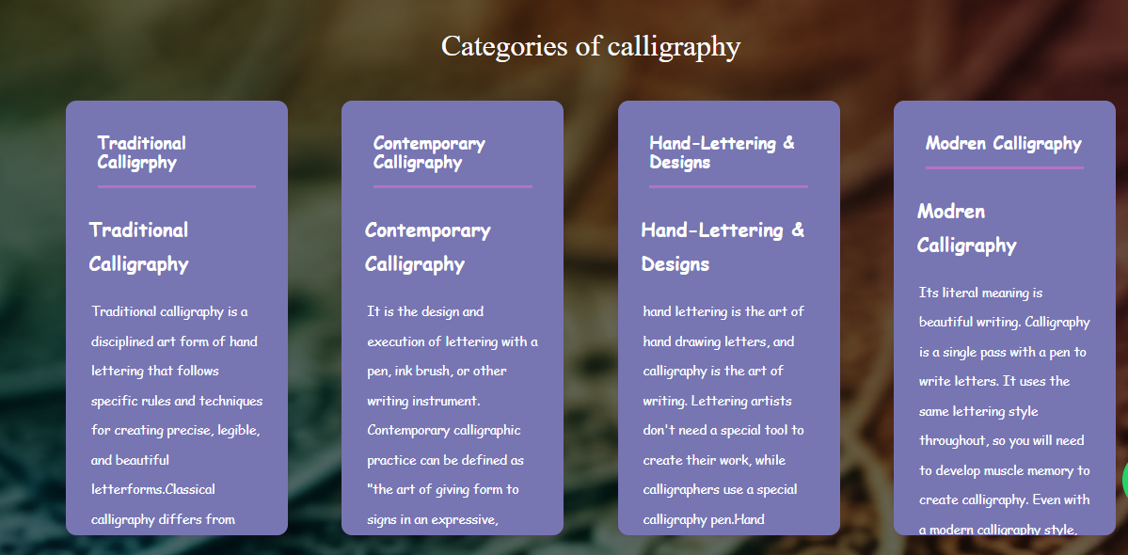

**Code**

**:** 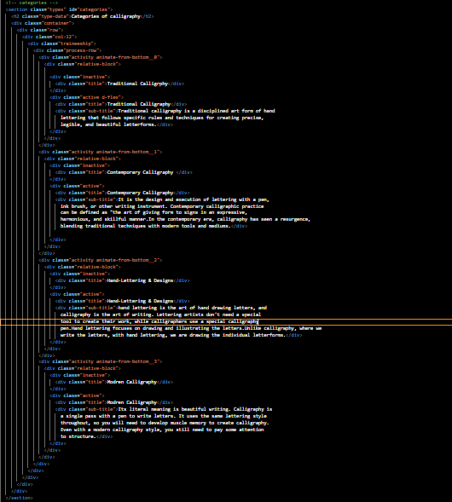

**4. Gallery:**

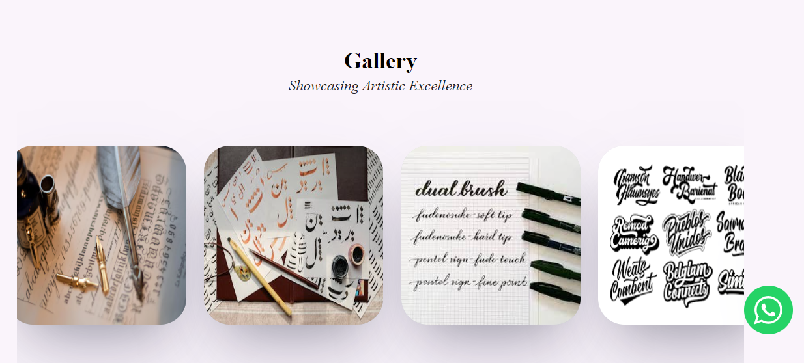

**Code:**

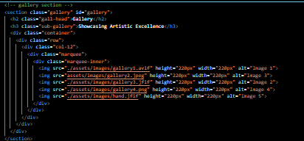

**4. Form & style:**

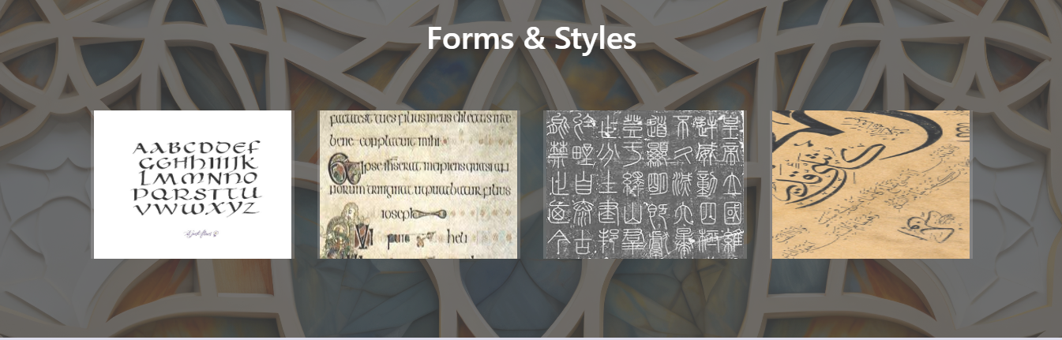

**Code:** 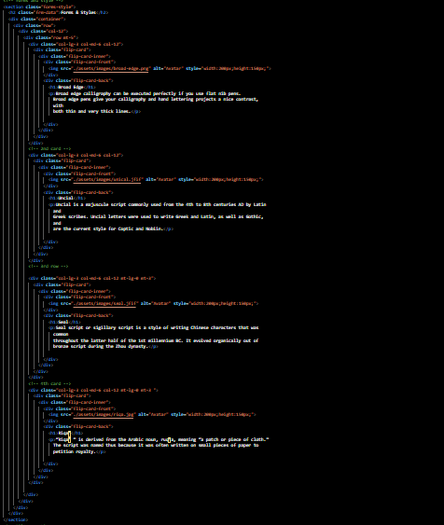

**5. Filter:**

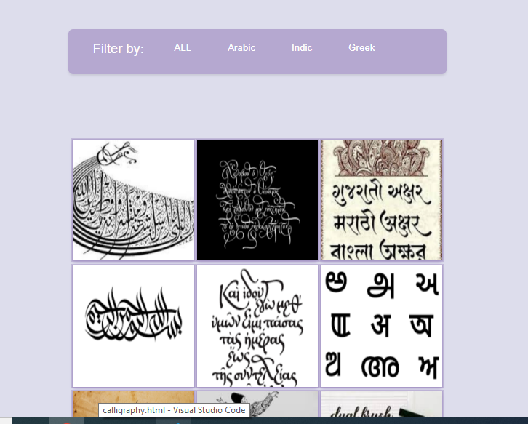

**Code:**

**­­**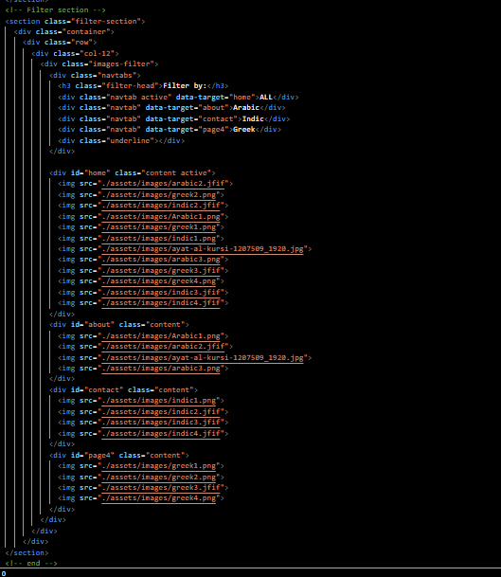

**6. Fonts & Letters:**

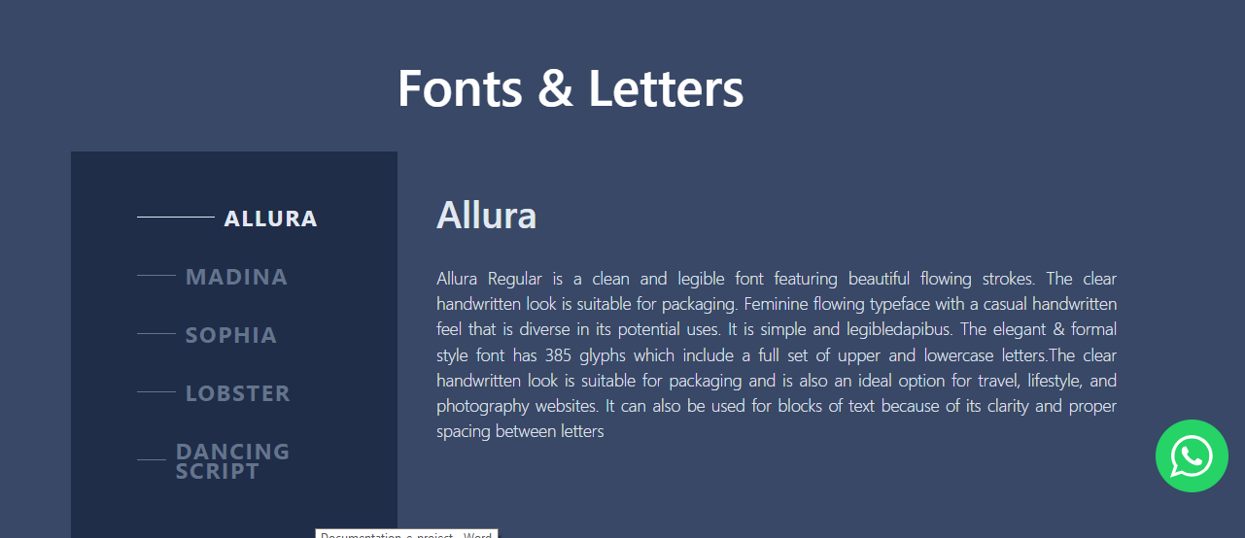

**Code:**

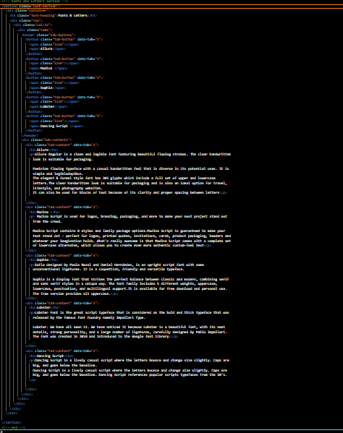

**7. Rating:** 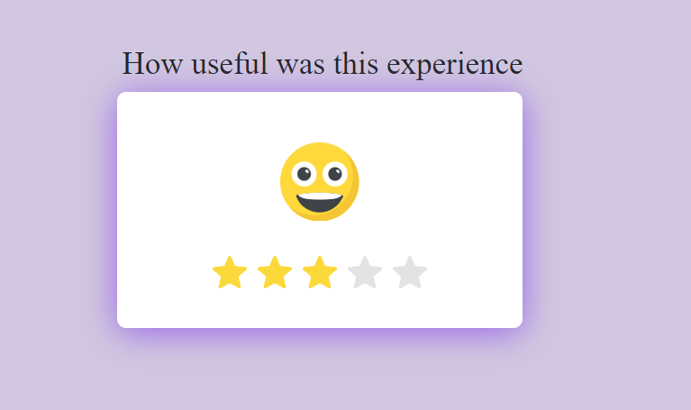

**Code:**

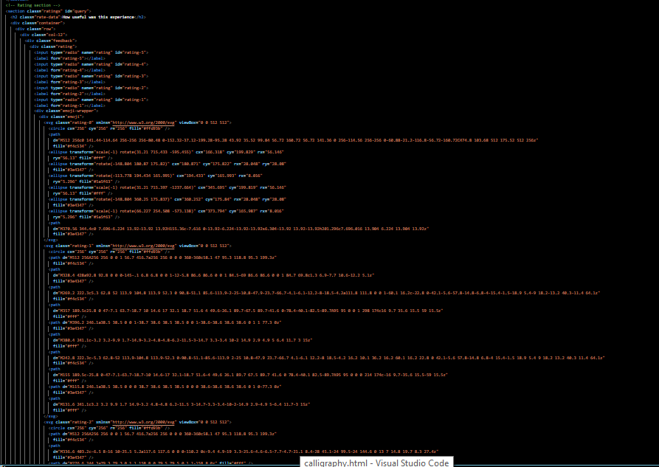

**8. Contact Us:**

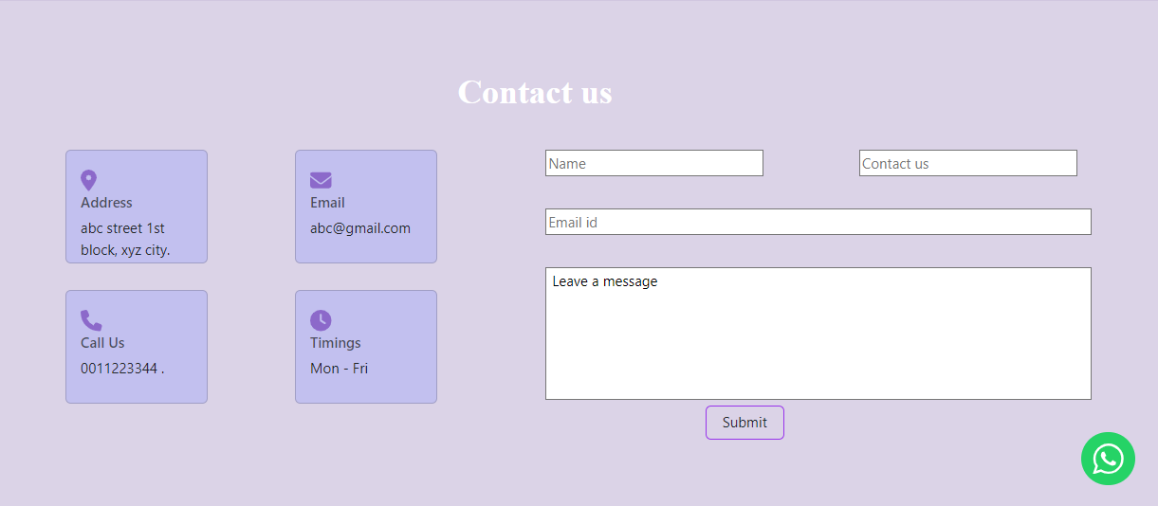

**Code:**

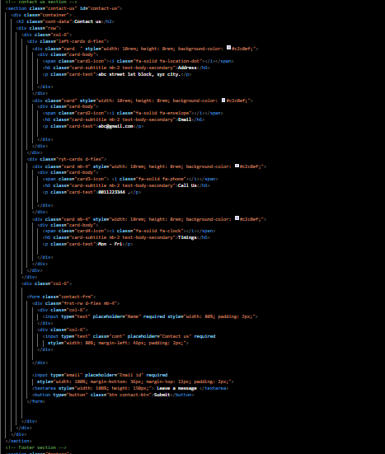

**9. Query link:**

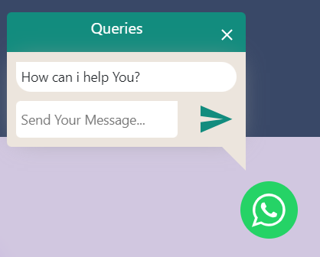

**Code:**

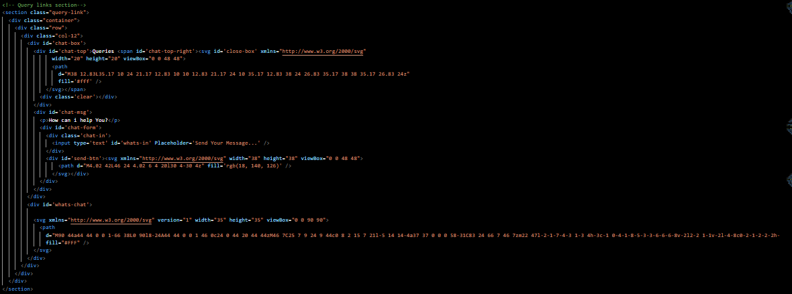

**10. Footer:**

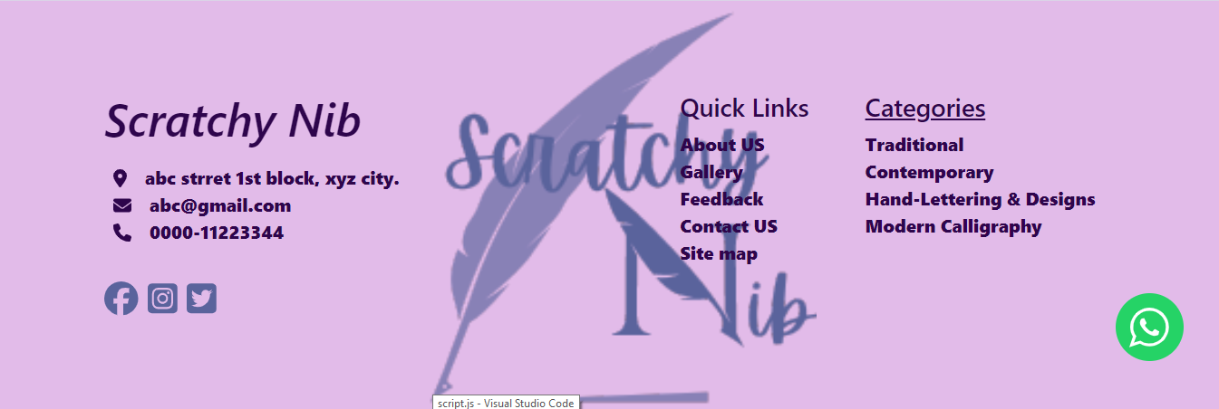

**Code:**

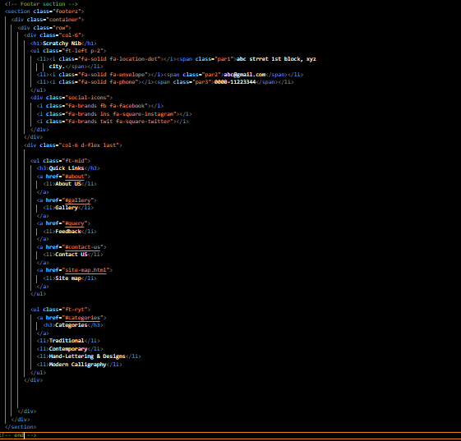

**Thank you!**